

IT Collect Vendor Onboarding

**March, 2021**

**General Services Administration**

**Office of Government-wide Policy**

**Table of Contents**

How do I authenticate with IT Collect? 2

How do the token transactions work between the user and IT Collect? 2

Authentication Example 2

How do I authorize new agency users to submit data to IT Collect? 6

How do I refresh an access token? 6

Refresh Access Token Example 6

How do I use the IT Collect API? 10

How do I contact ITDB / IT Collect Support? 10

# How do I authenticate with IT Collect?

1. Vendors will need to start by providing the IT Collect team with their redirect URLs and the subnets (IP Address range) of their staging servers that will be interacting with the IT Collect integration product.
2. Vendors will be provided their Client ID from IT Collect through an email from [itdb-support@gsa.gov](mailto:itdb-support@gsa.gov)
3. Finally, vendors need to have an account with Login.gov. The IT Collect Team uses Login.gov as a multifactor authentication and identity proofing platform. Agency assigned users to IT Collect are required to register with Login.gov and pair their government issued PIV/CAC card as MFA. Instructions to create a Login.gov account can be found at [this link](https://login.gov/create-an-account/).

## How do the token transactions work between the user and IT Collect?

*The diagram below is purely illustrative and does not capture all the components of authenticating with IT Collect (E.g., refresh tokens are not covered)*

1. Agency users start by requesting authentication with IT Collect from their vendor application.
2. Users are redirected to the IT Collect OAuth Server, wherein they are asked to login.
3. Users must click Login with Login.gov. For Login.gov account creation, see above.
4. Users are taken to Login.gov where they must provide their username, password, and PIV card.
5. Once the user has submitted this information and proved their identity, an access token is returned to the callback/redirect URL.
6. From here, agency users can send requests to IT Collect in which a response will be returned.

## Authentication Example

In the following example, we have used Postman as our API client, though agency users can use any API client or application they wish to authenticate with IT Collect.

1. Start by downloading IT Collect’s API schema at [this link](https://gsa.github.io/ITDB-schema/).
2. Open Postman, click Import at the top, and Upload the schema downloaded in step 1.
3. IT Collect will now appear on the left-hand side of Postman as seen in the screenshot below.

1. Hover your mouse over the IT Collect collection and click the ellipses (3 dots), then click Edit as seen in the screenshot below. *(note: you do not need the IT Dashboard collection)*

1. Once in Edit Collection, click the Authorization tab and enter the following information:
   1. Grant Type: *Authorization Code*
   2. Callback (Redirect) URL: *Check “Authorize using Browser” to redirect back to Postman. In practice, this will be your vendor application URL.*
   3. Auth URL: <https://dev-itcollect-oauth.itdb.boozallencsn.com/oauth/authorize>
   4. Access Token URL: <https://dev-itcollect-oauth.itdb.boozallencsn.com/oauth/token>
   5. Client ID: *Provided to you via email from the IT Collect team*

1. On the same screen, scroll down and click “Get New Access Token”. Your default browser will open and take you to the IT Collect API OAuth page. Once here, click “Log in with Login.gov”.
2. You will be directed to Login.gov where you can sign-in with your Login.gov account information and PIV/CAC card. You should already be registered with Login.gov at this point. If you are not, please visit their site at [this link](https://login.gov/create-an-account/) and create your account.

**Select here to log in with your PIV/CAC card**

1. Your browser will confirm once you have authenticated with Login.gov. From here, you may need to click the pop-up at the top of your browser to be redirected back to Postman if pop-up blocker is turned on for your browser. Postman should show confirmation and then display your Access Token. Click “Use Token”.

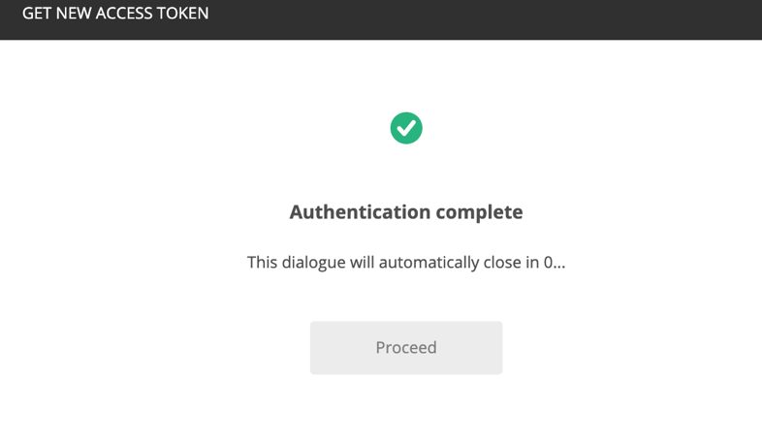

1. Lastly, click “Update” in the bottom right. You are now authenticated in Postman with IT Collect and can being using the API. Once again, there are many API clients or approaches to adding the IT Collect API schema, authenticating with OAuth, and using the API.

# How do I authorize new agency users to submit data to IT Collect?

IT Collect requires that Login.gov is set up; visit [this link](https://login.gov/create-an-account/) to create an account. Once that is complete, vendors and agencies are responsible for authorizing new submitters on their behalf.

# How do I refresh an access token?

Submit a refresh token to get a new access token. Please see the example below in Postman to see how this works. The expiration time on access tokens has not be finalized, but we will update the vendor community once it has.

## Refresh Access Token Example

In the following example, we have used Postman as our API client, though agency users can use any API client or application they wish to refresh their IT Collect access token.

1. Start by hovering your mouse over the IT Collect collection and click the ellipses (3 dots), then click Edit. *(note: you do not need the IT Dashboard collection)*

1. Once in Edit Collection, click the Authorization tab, scroll down, and click “Get New Access Token”.

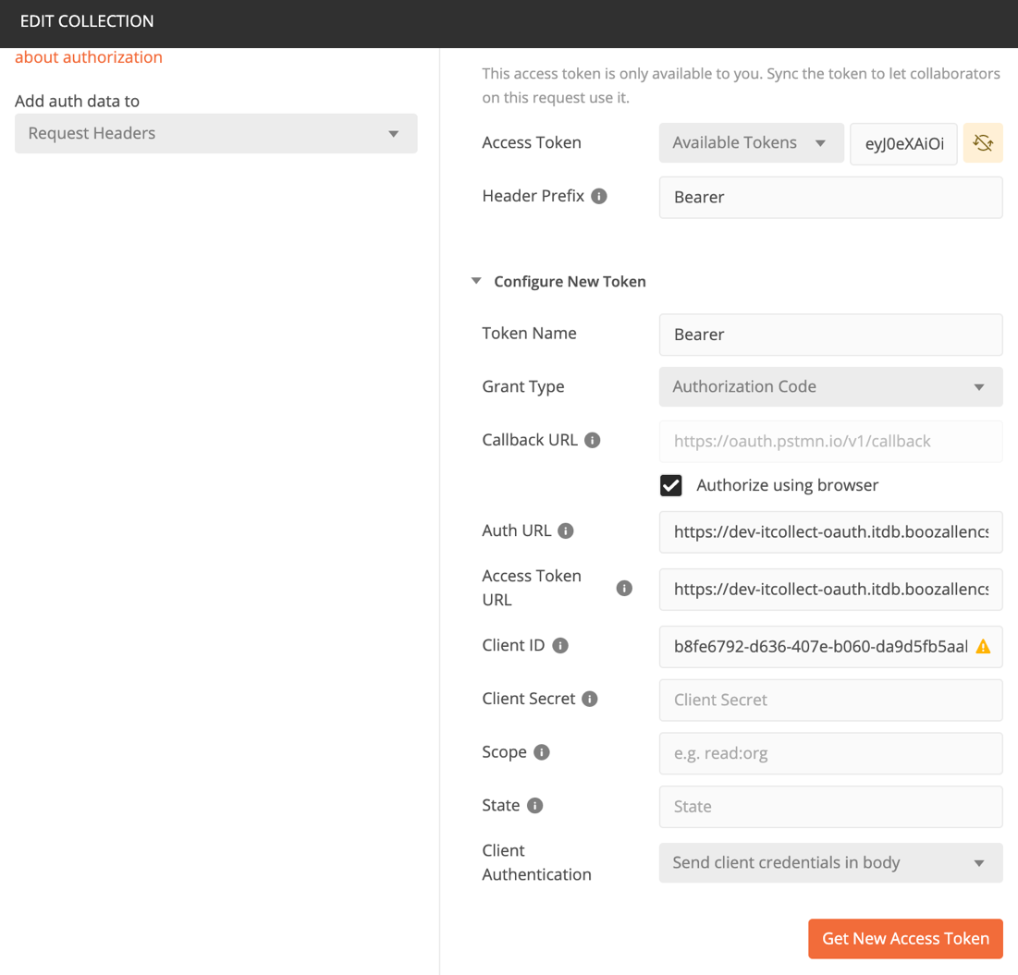

1. Your default browser will open, confirm you are authenticated with Login.gov (you will not need to authenticate, this is done automatically), and redirect you back to Postman. You may need to click the pop-up at the top of your browser to be redirected back to Postman if pop-up blocker is turned on for your browser. Postman should show confirmation and then display your Access Token. Click “Use Token”, then “Update”.

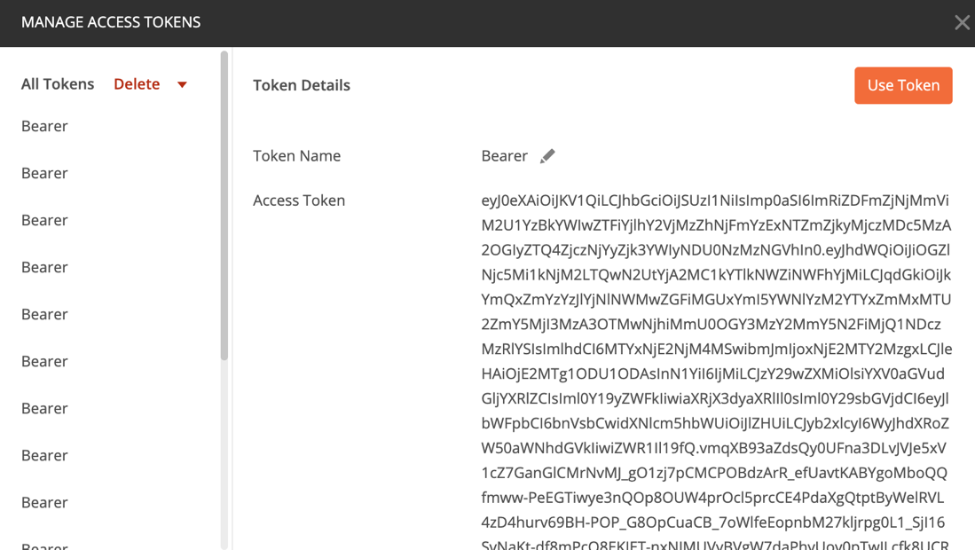

1. This concludes the access token refresh process using Postman. Once again, there are many API clients or approaches to adding the IT Collect API schema, authenticating with OAuth, and using the API.

# How do I use the IT Collect API?

For information on how to use the IT Collect API and answer your questions further, we suggest reading the IT Collect API Documentation, FAQ, and Ledger “How To” document seen here:

The **IT Collect API documentation** can be found at [this link](https://gsa.github.io/ITDB-schema/). This document highlights the data architecture, API schema, and authentication approach in IT Collect. Please note that this documentation will be continually updated automatically as the code is updated, but vendors can assume no major structural changes to the released data architecture.

The **IT Collect FAQ document** can be found on the Public GitHub at [this link](https://github.com/GSA/ITDB-schema/tree/master/IT%20Collect%20Docs). The FAQ outlines questions that have frequently come up in meetings and exchanges between vendors and the IT Collect team. The topics covered in the document are:

* Timeline
* Authorization
* Data Architecture / API Schema
* Validation & Errors
* Documentation
* Submission
* Rebaselines

*[Coming Soon]* The **IT Collect Ledger “How-To” document** can also be found on the Public GitHub at [this link](https://github.com/GSA/ITDB-schema/tree/master/IT%20Collect%20Docs). The Ledger “How-To” covers questions we anticipate and have heard around Ledger submissions.

# How do I contact ITDB / IT Collect Support?

For further information or questions about IT Collect and the legacy ITDB, or scheduling a technical walkthrough, please email our support team at [**itdb-support@gsa.gov**](mailto:itdb-support@gsa.gov)